BULLDOG MEDIA MOMENT@ DHS
A newsletter with media center updates along with technology tips and tricks you can use.
Issue #4 2011-2012, December 2012

The Month in Review – November
- 18 teachers used the media center, representing 124 classes.
- Closed in the mornings for 7 days due to FCAT retakes.
- Added 30 new books to the collection
- This month we were happy to have served the following numbers of students:
712 students before school
932 students during lunch
612 students throughout the day on passes

Book Mark Contest Sponsored by DHS Literacy Team
A book contest is being sponsored by the DHS Literacy Leadership Team. Students could be participating in the contest with their reading teachers, language arts teachers or art teachers. Any student who is not making a book mark in any of their classes may pick one up in the media center. All book marks must be turned in by December 13th. Bookmarks should be turned in to the media center or Mrs. Lowry’s mailbox. Prize winners will be announced during exam week. Winning bookmarks will be displayed at Family Literacy Night on Jan 31st, in the media center and at the VC Literacy Fair, held in the spring.

MEDIA CENTER WINTER WONDERLAND
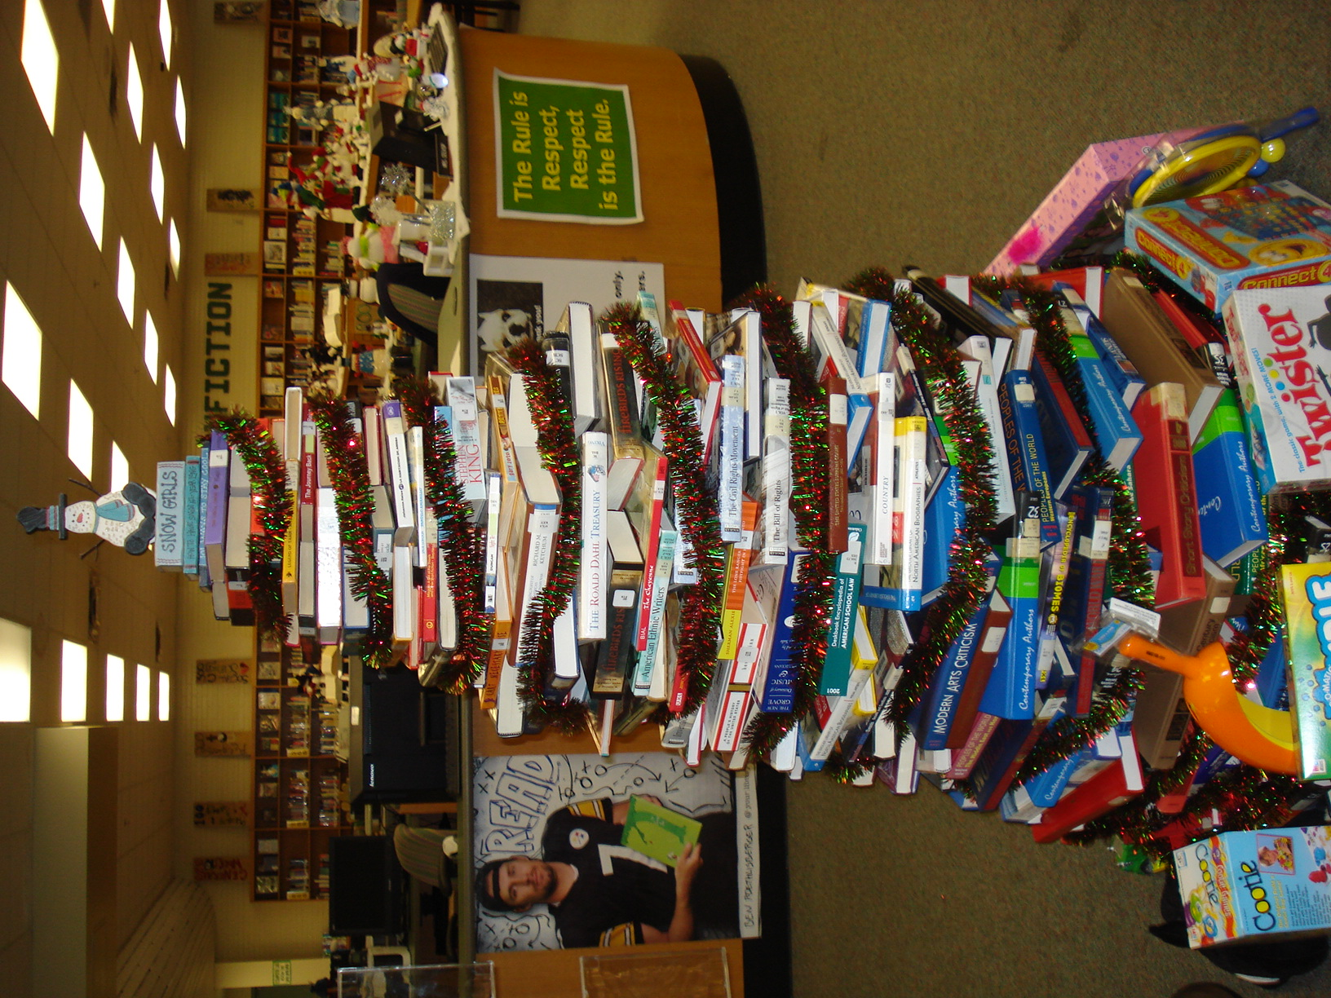
It’s the time of the year when the media center becomes a winter wonderland. See if you can pick out the new snowmen. Something else new this year is a tree made out of books. Of course, the tree topper is a snowman. The first period student office assistants: Dasia Horn and Amber Robinson helped create the tree. Please complement them on a job well done. Stop in and take a look.

TOY DRIVE and FREE COFFEE

TOY DRIVE AND FREE COFFEE
In the spirit of the holiday season and as a way to give back to those who give, any student who participates in the toy drive, by dropping off their toy in the media center, will receive a free cup of hot or iced coffee. Please remind students that the toys must be new.

Media Center Website
With the help of one of Ms. Oley’s students Akhil Patel, we have launched a new Media Center Website. The goal was make this site more informative and interactive for students, teachers and parents. To check out the new site, go to the DHS homepage, on the menu at the top choose Academics, and then choose Media.
If anyone would like us to add a link for your classes, please let us know as we would be happy to do so. Check it out!

January Literacy Calendar Contest
To celebrate National Literacy Month in January, we again will have a Literacy Calendar Contest. Each school day, students are asked to complete activities related to literacy. The Grand Prize is a Nook. Other student prizes include Prom Tickets, an IPod Shuffle and a gift certificate to Olive Garden. In the case of a tie, winners will be determined by a drawing. The teacher with the highest percentage of students participating will receive a restaurant gift certificate. If you would like to make this a class activity, please email me, before Dec 15th, how many calendars you will need for your students. Students may also pick up a calendar in the media center starting January 7th. All calendars must be turned in Feb 1st.

Thank you for your continued support of our program.
Please let us know how we can support you!

Happy Holidays

