Dear Parents:

As you may know, this year we’ve been using Edmodo in our classroom. Edmodo is a safe social learning platform that lets our class connect both at school and from home.

I am pleased to announce that Edmodo Parent Accounts are now available, and I’d like to invite you to join our classroom online.

With your Parent Account, you can:

- Send messages to your child and me, either together or individually
- View homework assignments and due dates
- Stay up to date on your child’s grades
- Receive updates on class and school events

Join our classroom on Edmodo in a few simple steps:
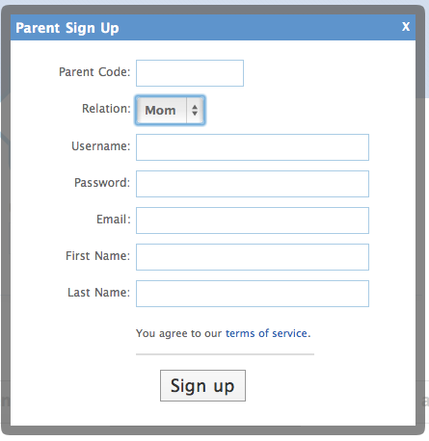
- Go to www.edmodo.com

- Select “Parent Signup”

- Type your code: [XXXXXXX] in the Parent Code field, then create your username and password. After you sign up for the first time, you will no longer need the parent code to log in, and will simply use your username and password.

- Select “Sign Up”. That’s all there is to it!

Note: Once you have registered, be sure to set your notifications in the Settings menu so that you can receive alerts and important classroom updates via email and/or text message.

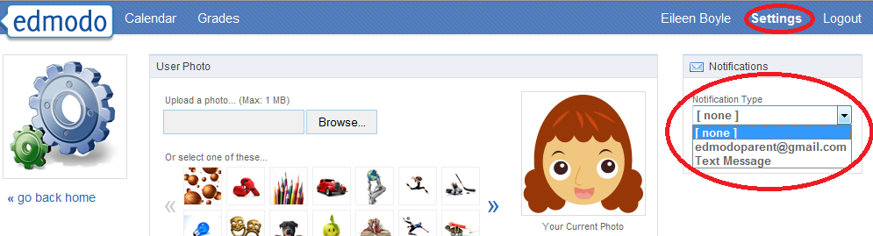

Let me know if you have any questions. I look forward to connecting with you on Edmodo!

Sincerely,

